Domestic violence cases jump 30% during lockdown in France
By Euronews • last updated: 28/03/2020
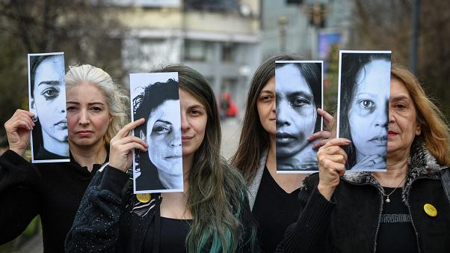
Women's rights activists hold printed half face pictures showing victims of domestic violence during a protest in Bucharest on March 4, 2020 - Copyright DANIEL MIHAILESCU
France's interior minister says that reports of domestic violence across the country have jumped by more than 30% since the country went into lockdown on March 17th.
Christophe Castaner revealed on Thursday that in Paris alone, cases were up by 36%.
France's anti-coronavirus lockdown has forced people to stay home for the last 11 days. The lockdown has now been extended until April 15.
Being confined at home with abusive partners is thought to have increased the risk to victims.
France already has one of the highest rates of domestic violence in Europe. Every year, an estimated 219,000 women, aged 18 to 75, face physical or sexual violence by current or former partners, but only 20% report it. According to official figures, one woman is killed by a partner or former partner every three days.
Castaner said that the government would introduce new measures to allow people facing abuse to call for help during the lockdown.
Victims will be able to call for help in pharmacies, he said. "A woman who is suffering from domestic violence, when she goes to the pharmacy without her husband, must be able to call for help."
He added that a code system would be developed for victims whose violent partners had accompanied them to a pharmacy,
Spain already has a code system for reporting domestic violence.
Castaner said that, as the lockdown continues, the police will be on high alert for reports of abuse, and that fighting domestic violence is a priority.
Currently, victims of domestic violence in France can call 3919 for help.

